**1. Program to find the largest of 03 numbers**

Exp O/P: Largest = ? using nested if statement, ladder if statement, ternary operator

**2. Program to check whether a number is odd or even**

**3. Program to display first "n" odd numbers**

Exp O/P: 1 3 5 7 ......

**4. Program to display the even numbers between x & y**

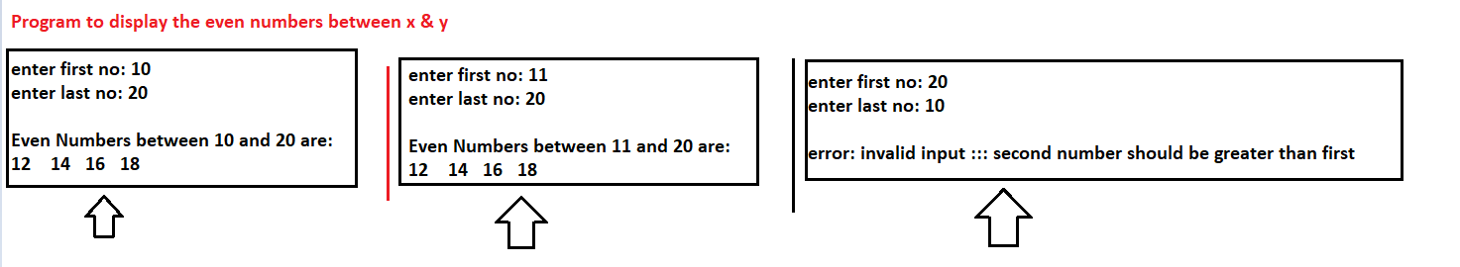

**5. Program to reverse a number; For example , if the number is 9835 , then O/P should be 5389**

**6) Program to find the sum of digits of a number**

**7) Display the first 15 elements of the following sequences**

1 4 7 10 ..

**8) Display the first 15 elements of the following sequences**

1 2 4 8 ..

**9) Display the first 15 elements of the following sequences**

0 1 1 2 3 ....

**10) Display the following Patterns:**

*

* *

* * *

* * **

* * ***

**11) Display the following Patterns:**

1

1 2

1 2 3

1 2 3 4

1 2 3 4 5

1 2 3 4 5 6

1 2 3 4 5 6 7 8

1 2 3 4 5 6 7 8 9

**12)**

